

Tesco International Intactix Implementation

Logical Module Numbering

Functional Specification
Version  Version Date  Author | : 1.1  : 31/01/2007  : Chris Goldney | JDA International Ltd  3 The Arena  Downshire Way  Bracknell  RG12 1PU  Berks  Tel: UK +44 (0)1344 354500  Fax: UK +44 (0)1344 354544

Version History

Version | Date | Author | Description
1.0 | 22/01/2007 | Chris Goldney | Initial Release
1.1 | 31/01/2007 | Chris Goldney | Addition of regeneration criteria for generated location IDs

Contents

1 Business Requirement 4
2 Current Functionality 4
3 Definition 4
4 Assumptions 4
5 Modification Scope 4
6 Process Flow Diagrams 4
7 Pre-Requisites 4
8 Modification Detail 5
9 Modification Testing 9
10 Technical Considerations 10
11 Glossary Of Terms 10
12 Appendix 1 – Sample Screenshots of Desired Generated Fixture Location ID Ordering 11
13 Signoff Sheet from Customer 13

Business Requirement
Tesco requires each module (planogram segment) within a store to be identified for reporting and printing purposes. Modules will also be ‘tagged’ in store with an identification number as defined by its location on the floorplan. In the absence of segment identification in core Floor Planning, fixtures will provide the module number.

The ordering of location Ids needs to be capable of ‘snaking’ around designated fixture groups in Floor Planning, so that fixture patterns that include end caps are logically numbered. The user will assign multiple fixtures to a fixture ‘group’ using a property list in Floor Planning. Once fixtures are assigned, processing will generate a unique module number when the floorplan moves to Awaiting Sign Off. This processing will take account of all floors in the store to ensure the uniqueness of the module number.

Future versions of a floorplan must retain the original module numbers, i.e. the module number must not be regenerated each time a version of the floorplan goes to ASO. This is to prevent manual reassignment of module numbers in-store following a space change. On this basis, the only time a module number needs to be regenerated is for additional fixtures that have been added to a fixture group.

Current Functionality
Current functionality in Floor Planning allows the fixture location ID to be automatically generated or manually assigned by the user. Neither of these methods was deemed appropriate to Tesco.

Definition
This functionality is based on IKB 2006.2
Tesco will run IKB on Microsoft SQL Server 2005.

Assumptions
Fixtures will be assigned to a floorplan as individual module, i.e. each module will be representative of a single segment of a planogram.

The user will be able to manually adjust the generated fixture location ID if required.

This process only regenerates location IDs for all fixtures on the floorplan when all generated fixture location IDs are found to be zero or NULL. A business rule will be implemented to allow the user to set all generated location IDs to zero when the floorplan is at WIP status should a complete location ID regeneration be required.

Generated fixture location IDs will commence at 1, not zero.

Modification Scope

Scope  Number | Scope Description
 | Logical Module Numbering Generation
 | Logical Module Numbering Validation

Process Flow Diagrams

A process flow diagram is not applicable.

Pre-Requisites

None

Modification Detail

Scope  Number | Detail  Number | Detail Description
1 | 1.1  1.2  1.3  1.4  1.5  1.6 | Logical Module Numbering Generation  This is the scope for the generation of logical module numbers based on the positioning of fixture objects in Floor Planning.  The user will firstly assign a fixture ‘group’ code to each fixture using a property list in Floor Planning. Fixture group codes can be numbers or letters. Fixtures sharing the same fixture group code should be generated a location ID by the process. The concatenation of the fixture group code and the generated location ID, divided by a dash, constitutes the logical module number. An example of the logical module number is: A-12.  The generated fixture location ID should be generated based on logic described in the scenarios below. Fixture groups will be processed in ascending order. All fixtures within a fixture group will be allocated a location ID in order based on a user-defined origin point on the floorplan. This will be entered in floorplan value fields and will apply to all fixture groups on the floorplan.  The logical module number will be generated when the fixture group code and the generated location ID are not populated (i.e. are NULL). This means that the process should only regenerate all fixture location IDs for a floorplan created for a new store or for a floorplan that is not a copy of a live or pending floorplan. In circumstances where a copy of a live or pending floorplan is made (e.g. for a space change), the process will only generate a location ID for fixtures that are present on the new version but not on the old. Again, the process will generate a logical module number when the fixture group code and the generated location ID are not populated (i.e. are NULL).  The logical module number will be generated by a stored procedure which is run when the floorplan is moved from Work in Progress (WIP) to Awaiting Sign Off (ASO) in Floor Planning.  Additional validation will follow the generation of the logical module number to ensure that each is unique to the store in question. Please see modification scope 2 for further details.  A process is required when a WIP floorplan is moved to ASO in Floor Planning:  - Save the floorplan.  - Check if all of the fixtures have a fixture group code assigned:  - Loop through all fixtures associated to the floorplan.  - Check that fixture group code (ix_flr_fixture.Desc2) is populated (is NOT NULL).  - If a fixture has no fixture group code assigned the processing should fail and the user should be notified.  - If all fixtures have a fixture group code assigned the process should continue.  - If all fixtures have fixture group codes assigned, check if all fixtures have a generated location ID set:  - Loop through all fixtures on the floorplan:  - If all fixtures have generated location ID (ix_flr_fixture.Value2) set to NULL or 0 (zero), all fixtures should be processed.  - If some but not all fixtures have generated location ID (ix_flr_fixture.Value2) set to NULL or 0 (zero), only those fixtures should be processed.  - If all fixtures have generated location IDs present, no processing takes place.  - If all fixtures on the floorplan are to be processed:  - Identify the different fixture groups present on the floorplan:  - Process the fixture groups in turn working in ascending order based on the fixture group code. If both numbers and letters are used for fixture group names, process numbers first.  - Generate a logical location ID for each fixture in the fixture group:  - Locate the start fixture within the fixture group:  - Locate the fixture with X & Y origin points closest to the user-defined origin point X (ix_flr_floorplan.Desc5) and point Y (ix_flr_floorplan.Desc6)  - Set the generated location ID (ix_flr_fixture.Value2) to 1  - Locate the next fixture to be numbered:  - If there is a fixture adjacent to the start fixture, number this fixture next:  - Locate the fixture with the X & Y origin point closest to the start fixture  - If the X or Y location and the angle (ix_flr_fixture.Angle) is the same as the start fixture, the fixture is deemed adjacent.  - Set the generated location ID (ix_flr_fixture.Value2) to 2  - If there is not a fixture adjacent to the start fixture, locate the next closest fixture:  - Locate the fixture with the X & Y origin point closest to the start fixture  - Set the generated location ID to 2  - If there are no adjacent fixtures in the fixture group:  - Location IDs should be set based on the X and Y origin point of the fixture in relation to the first fixture numbered.  - Continue with this logic until all fixtures in the fixture group have a location ID allocated, checking for adjacent fixtures at all times.  - Note: please see Appendix 1 for examples of the numbering logic required.  - Move to the next fixture group and process until all fixture groups have generated fixture location IDs set.  - Once all generated fixture location IDs are processed, populate the module number field  - Populate the module number field (ix_flr_fixture_Desc3) with a concatenation of the fixture group code (ix_flr_fixture.Desc2) and the generated fixture location ID (ix_flr_fixture.Value2)  - If some but not all fixtures on the floorplan need to be processed:  - Identify the different fixture groups present on the floorplan:  - Process the fixture groups in turn working in ascending order based on the fixture group code. If both numbers and letters are used for fixture group names, process numbers first.  - Generate a logical location ID for fixtures in the fixture group that need one:  - Locate the start fixture within the fixture group:  - Locate the fixture with X & Y origin points closest to the X & Y origin points of the fixture in the fixture group with the highest generated fixture ID code (ix_flr_fixture.Desc2)  - Set the generated fixture location ID code to one more than the highest generated fixture ID code (ix_flr_fixture.Desc2) in the current fixture group.  - Locate the next fixture to be numbered:  - If there is a fixture adjacent to the start fixture, number this fixture next:  - Locate the fixture with the X & Y origin point closest to the start fixture  - If the X or Y location and the angle (ix_flr_fixture.Angle) is the same as the start fixture, the fixture is deemed adjacent.  - Set the generated location ID (ix_flr_fixture.Value2) to one greater than the start fixture  - If there is not a fixture adjacent to the start fixture, locate the next closest fixture:  - Locate the fixture with the X & Y origin point closest to the start fixture  - Set the generated location ID to one greater than the start fixture  - If there are no adjacent fixtures to be processed:  - Location IDs should be set based on the X and Y origin point of the fixture in relation to the first fixture numbered.  - Continue with this logic until all fixtures in the fixture group have a location ID allocated, checking for adjacent fixtures at all times.  - Note: please see Appendix 1 for examples of the numbering logic required.  - Move to the next fixture group and process until all fixture groups have generated fixture location IDs set.  - Note: if the majority of fixture groups do not have a generated fixture location ID set, the user would find it easier to manually delete those fixtures with values set and rerun the process as part of floorplan sign-off.  - Once all generated fixture location IDs are processed, populate the module number field for those fixtures assigned a generated fixture location ID  - Populate the module number field (ix_flr_fixture_Desc3) with a concatenation of the fixture group code (ix_flr_fixture.Desc2) and the generated fixture location ID (ix_flr_fixture.Value2)  - Note: once logical module numbering processing is complete, Object lifecycle processing will validate the assigned fixture module number to ensure that that module number is not in use on another floor in the store. Please see Object Lifecycles specification for further information.

Modification Testing
Functional Specification Reference | Version 1 |  | Test Author | Chris Goldney
Description | Logical Module Numbering |  | Test Date
Test Environment |  |  | Tester
Test Environment |  |  | Hardcopy test results attached  (Yes/No)
Test Type | Functional Test |  | Test Status - (Success/Failure)

No | Test Description | Expected Test Result | Actual Test Result | Success (Y/N)
 | TBC

Technical Considerations

None

Glossary Of Terms

IKB – Intactix Knowledge Base

Appendix 1 – Sample Screenshots of Desired Generated Fixture Location ID Ordering
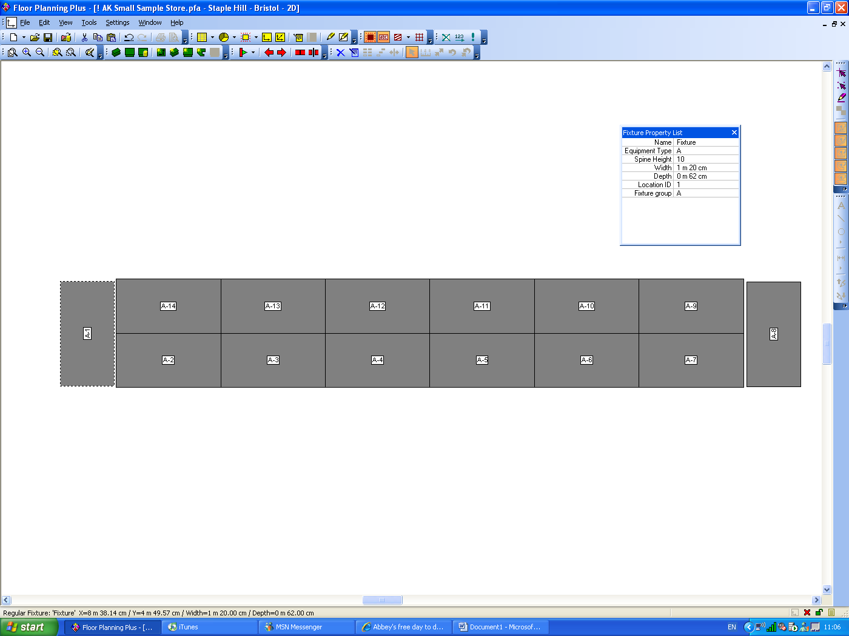
Simple example of required solution:
More advanced example of required solution:

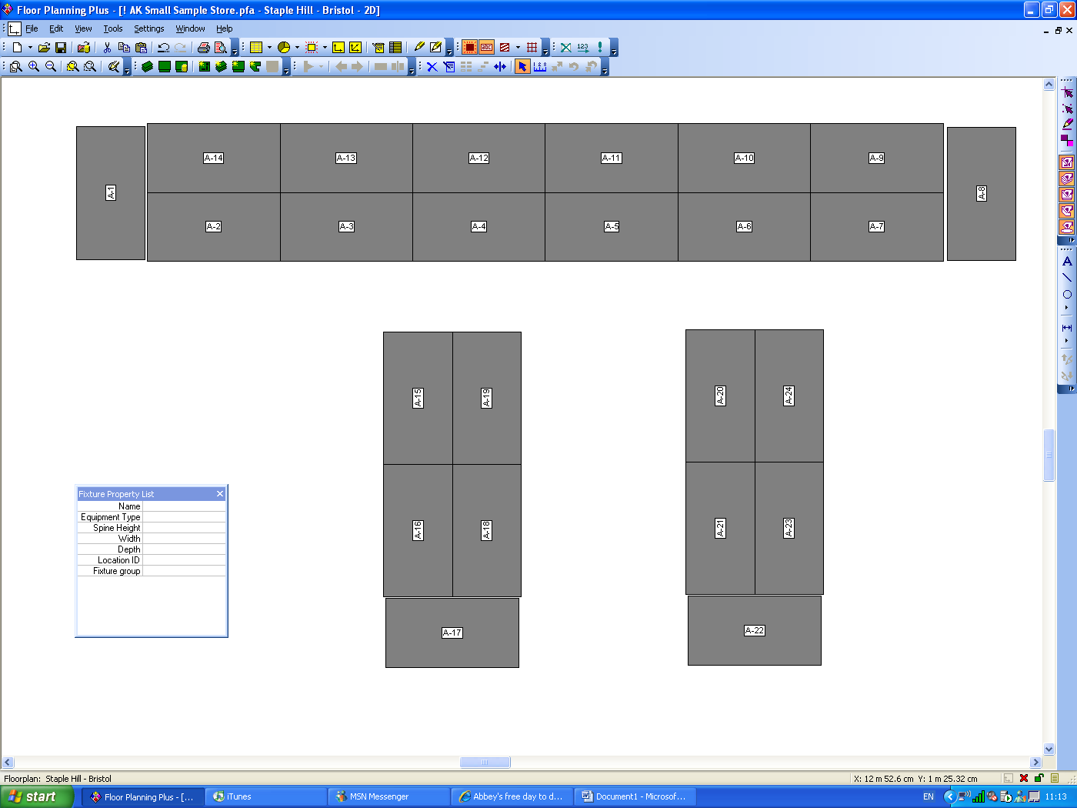

Signoff Sheet from Customer

Customer | Tesco
Project | I56 – Tesco International Intactix Implementation
Module | 01 - Logical Module Numbering
Functional Specification Version | 1.0
Functional Specification Issue Date | 22/01/2007

The signatories below accept that the functional specification and version, as described above, describes the requirement and authorise JDA to develop the functionality.

Customer Sign Off
Name: | Eva Hotmarova
Title: | Project Manager
Signature: |  | Date:
Name: | Samantha Baptiste
Title: | Business Analyst
Signature: |  | Date:
Name:
Title:
Signature: |  | Date:
JDA Sign Off
Name: | Stuart Smith
Title: | JDA – Project Manager
Signature: |  | Date:

